Brief Report on assignment2

Hao Liu

1. correctness of software:

In order to verify the function of this software, simply run the first program with parameter k = 5, p =0.4, and we get a matrix, like this:

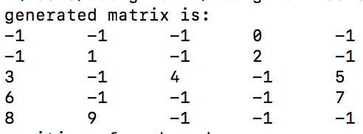

The node with number “-1” indicates that this is an uncolored node, and number 0~9 is the number for colored nodes. Data these nodes are output to a txt file:

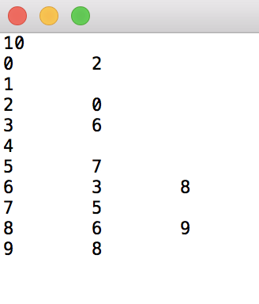

As we can see from above, the correctness of first program has been proved.

Then run the second program to read these data in and do some analyze, after analyzing, data are put into another txt file:

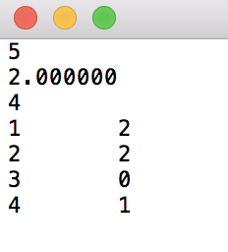

As we can see in the picture above, the analyze of data is also correct, so the second program is right.

1. relationship between largest size of components and P:

Let p been fix with 0.1 , change the size of matrix from 5\*5 to 45\*45 and observe how max component vary:

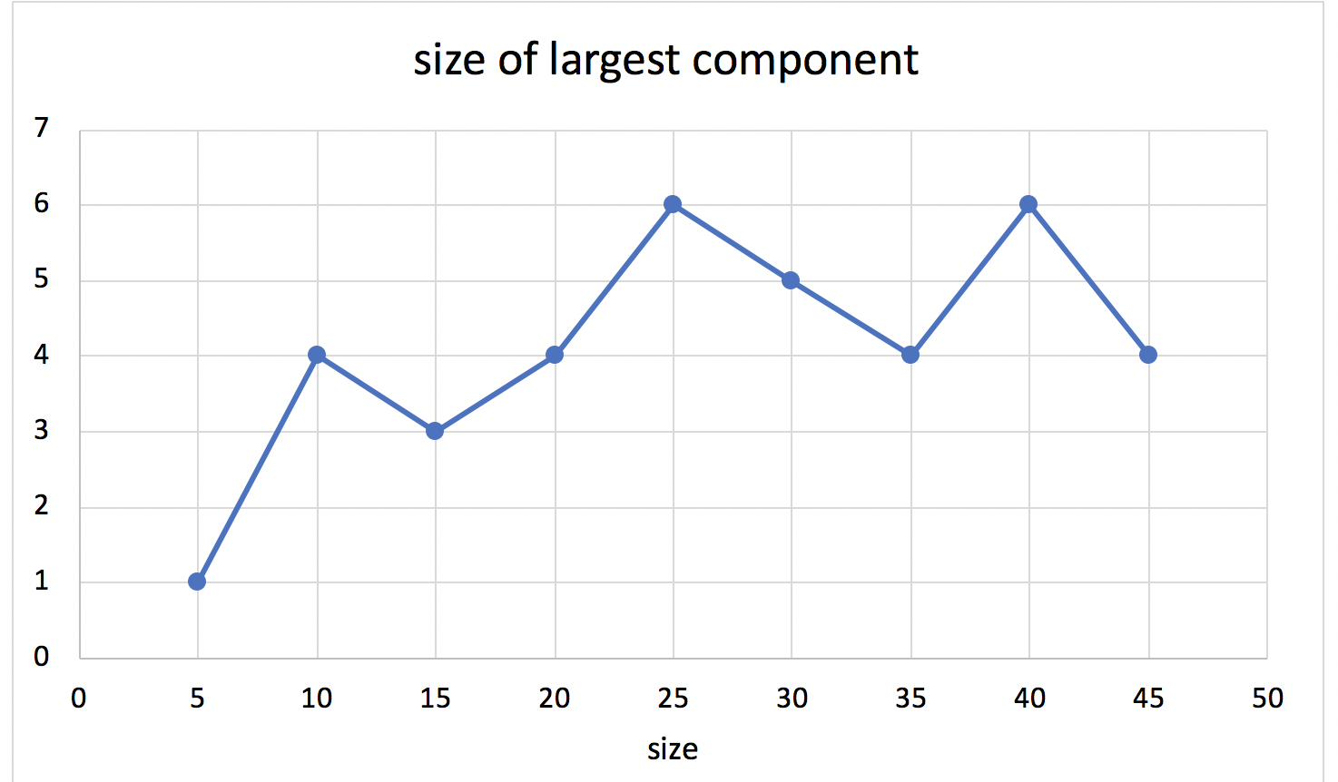

It seems that no matter how big this matrix is , the max component size remain in 4~6, it do not change largely.

Then let p fixed with 0.9, change the size of matrix from 5\*5 to 45\*45 and observe how max component vary:

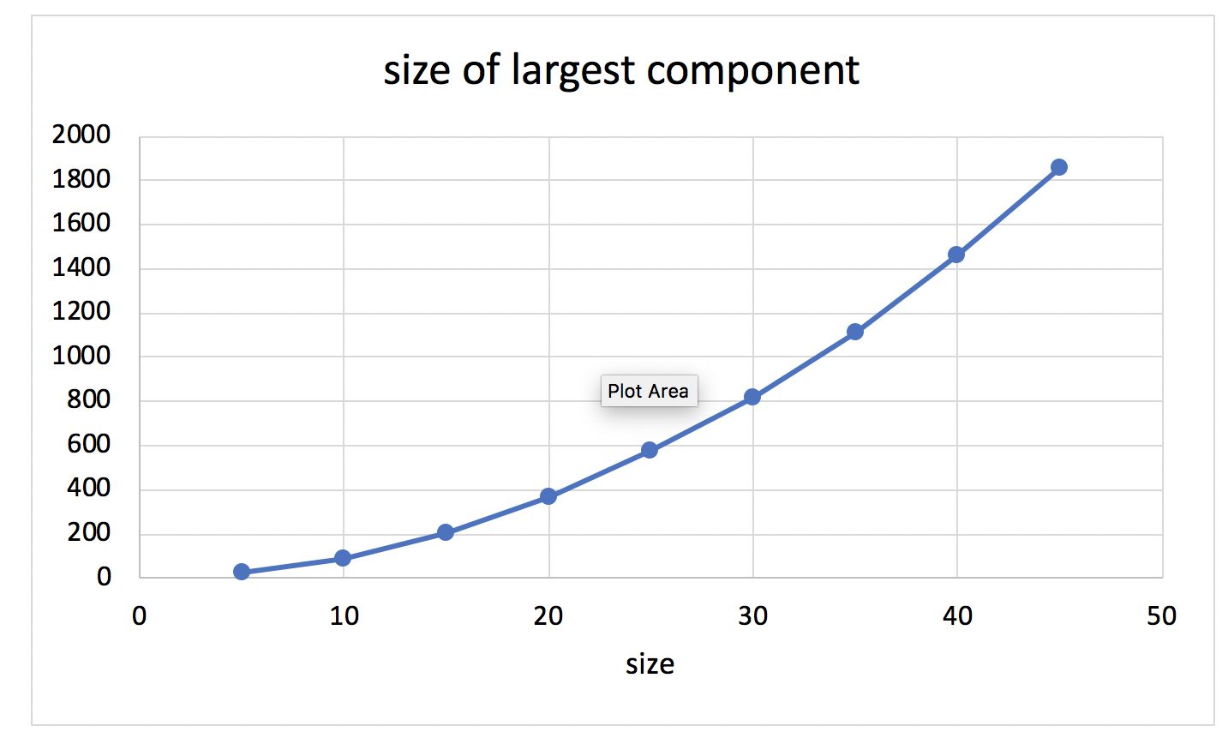

When p is 0.9, obviously, max component size change correspondingly with the size of matrix.

So, in general, when P is low, the size of largest component do not change with the size of graph, however, when P is high, the size of largest component with increase when the size of graph increases.